Prototype Assignment
You are required to develop a web application with the requirements given below:

User Management
- The system shall allow:
  - User registration, login, logout
  - Password encryption
- The system shall support:
  - Role-based access control

User Interface

The system shall display the homepage upon opening the website or application.

The homepage shall contain a header with the logo, navigation menu (Home, About, Submit Symptoms, History, Login), and optional user profile icon if logged in.

The homepage shall include a main section with a prominent text input box for users to type symptoms.

The homepage shall provide placeholder text in the input box guiding users: "Type your symptoms here (e.g., fever, headache, body pain)".

The homepage shall have optional dropdowns or selection fields for:

Severity (Low, Medium, High)

Duration (Hours, Days, Weeks)

Symptom Submission

The homepage shall have a “Diagnose Me” button that submits the user input to the system.

When the user submits symptoms, the homepage shall validate that the input is not empty.

If the input is empty, the system shall display a warning message prompting the user to enter symptoms.

Upon valid submission, the homepage shall redirect the user to the Results Page showing predictions, confidence scores, and explanation.

Natural Language Input Module (NLP Engine)
The system shall accept:
- Free-text input (English)
- The system shall:
- Perform:
  - Tokenization
  - Stop-word removal
  - Lemmatization/stemming
- Extract:
  - Symptoms
  - Duration
  - Severity indicators
- The system shall map extracted text to standard medical terms
- Example:
  - Input: "I have high temperature and severe headache"
Output: [fever, headache]
- The system shall:
  - Handle spelling mistakes
  - Suggest corrections

Symptom Normalization & Dictionary
- The system shall maintain:
  - Symptom ontology/dictionary
- The system shall:
  - Map synonyms:
    - “temperature” → fever
    - “stomach pain” → abdominal pain
- Admin shall:
  - Add/edit/remove synonyms

Feature Engineering Module
- The system shall convert symptoms into:
  - Numerical feature vectors
- The system shall include:
  - Binary encoding (present/absent)
    - Converts presence/absence of symptoms into 0 or 1.
    - Example:
fever → 1 (present)
cough → 0 (absent)
    - Purpose: Lets ML models distinguish which symptoms are reported.
  - Severity Weighting
    - Assigns numeric values to symptom severity.
    - Low → 1, Medium → 2, High → 3
    - Purpose: ML models consider not just presence but how severe the symptom is.
  - Duration Encoding
    - Converts symptom duration into numeric values:
    - Short → 1, Medium → 2, Long → 3
    - Purpose: Longer-lasting symptoms might have higher significance in diagnosis.
  - Vectorization
    - Combines all features into a single feature vector for the ML model.
    - Example:
[fever=1, headache=1, cough=0, severity=3, duration=2]
    - Provides a structured input that the ML algorithms can process efficiently

Input Data Set:
- Prepare a input data set
- Sample:
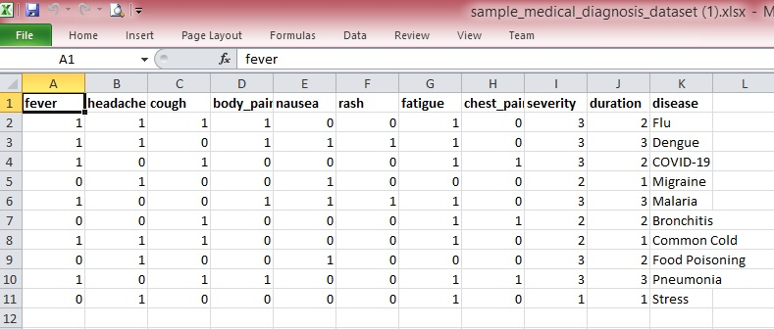

- Add as many as possible diseases and all possible symptoms of a disease.

